MW6-How to use Amazon Alexa with Tenda WiFi System
The document applies to users who connect Amazon echo to the Internet by using mw6
Step 1: Connect Amazon echo to the Internet by using mw6
1.1 Download the Alexa App, and setup your Amazon echo.
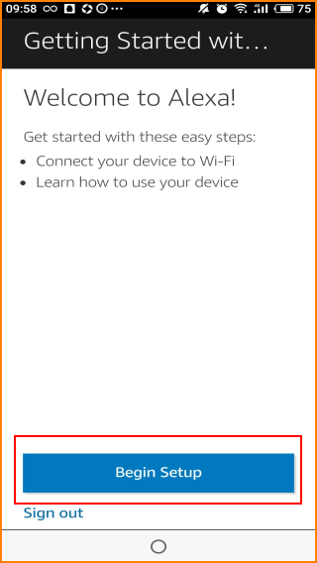
1.2 Begin Echo Setup. On your Echo device, press and hold the Action button until the light ring changes to orange, manually connect to your amazon device.
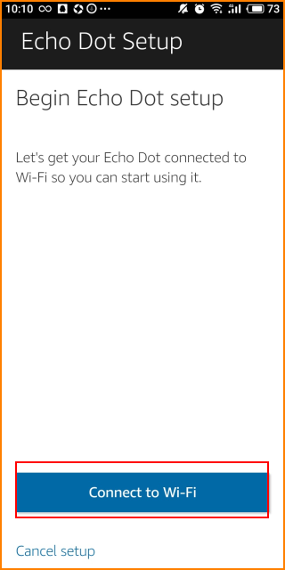
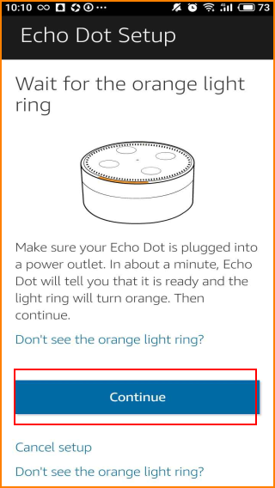
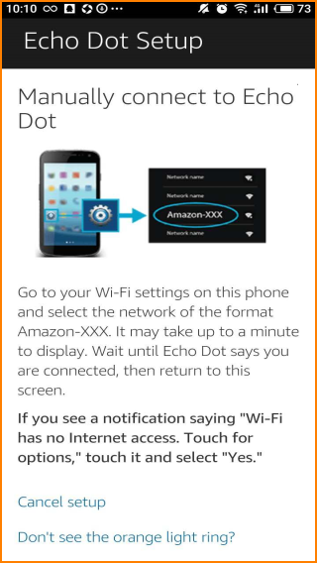
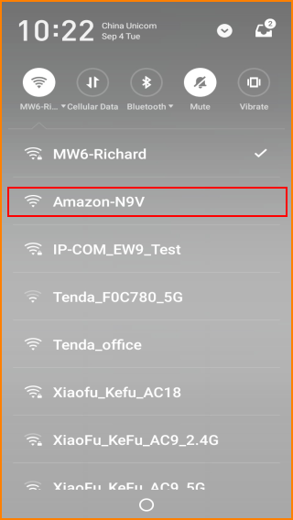
1.3 Select MW6 Wi-Fi network and enter the network password. Then press the connect button. Waiting for a few minutes, then, you can use your echo device.
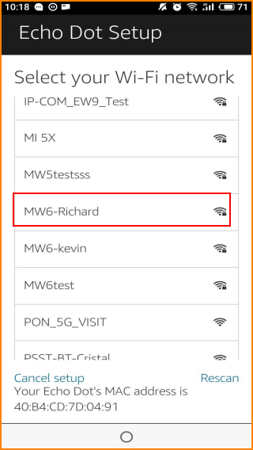
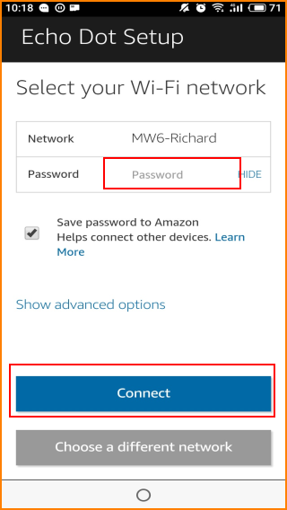
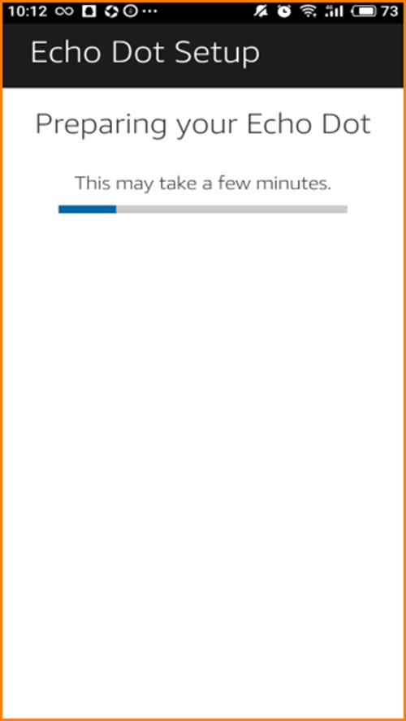
Step 2: Use Amazon Echo Dot with Tenda WiFi System
Now you can use Amazon Alexa with Tenda WiFi System, Your Amazon Echo can give you up-to-the-minute weather. here’s how to use this function with Tenda WiFi System.
2.1 If you want to adjust the weather settings, first, tap “Settings”
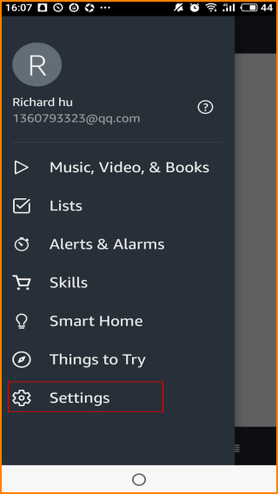
2.2 Tap “your device”
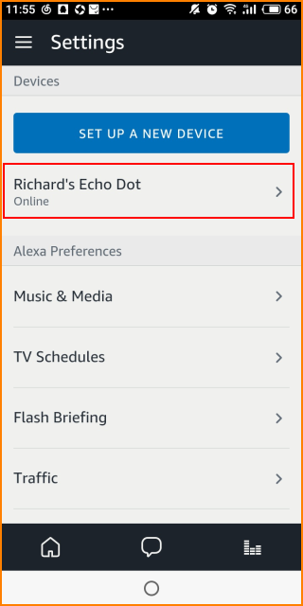
2.3 Drop-down interface and tap “Device location”
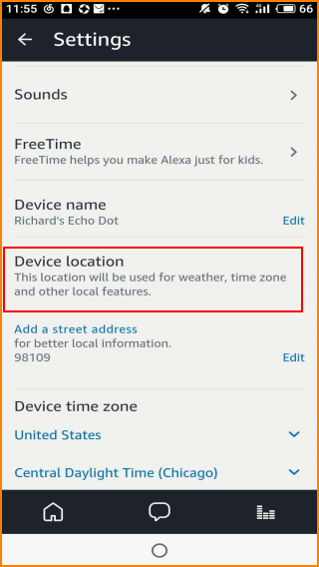
2.4 change the location and input your address
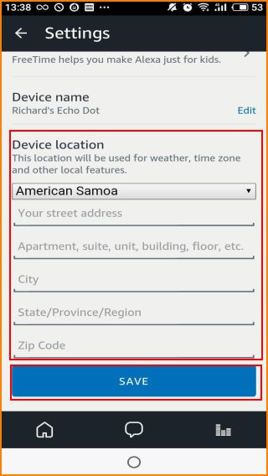
2.5 Now you can ask Amazon echo about local weather and temperature.

